NAME:K.SAI PRAKASH

PIN NO:19485A0419

**IOT ASSIGNMENT-2**

**AUTOMATIC GARAGE DOOR OPENING SYSTEM**

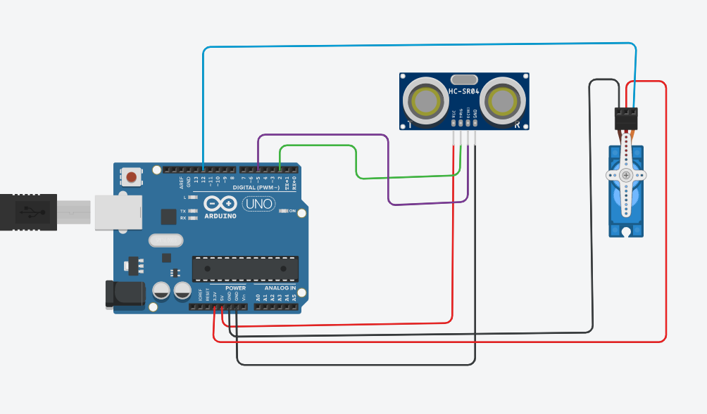

#include<Servo.h>

Servo myservo;

int trigpin=2;

int echopin=5;

void setup()

{

pinMode(trigpin,OUTPUT);

pinMode(echopin,INPUT);

myservo.attach(12);

Serial.begin(9600);

}

void loop()

{

digitalWrite(trigpin,HIGH);

delay(1000);

digitalWrite(trigpin,LOW);

float duration=pulseIn(echopin,HIGH);

float distance=(duration*0.034)/2;

Serial.println("the distance is");

Serial.println(distance);

if(distance<=100)

{

myservo.write(90);

Serial.println("servo is at a angle 90");

delay(1000);

}

else

{

myservo.write(0);

Serial.println("servo is at a angle 0");

delay(1000);

}

}

